Tenda AC5-How to set up parental control
Model Number: Tenda AC5
Question Classification: Function Setting

Step 1: Open a browser and type tendawifi.com in Address Bar, tap “Enter”. Input login password and tap “Login”.

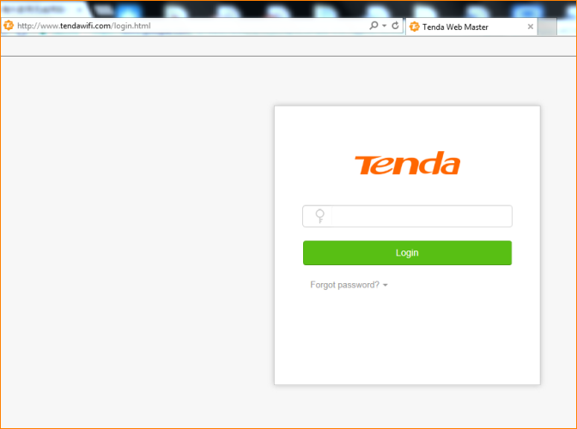

Step 2: Tap “VPN” tap the to choose the device you want to manage.

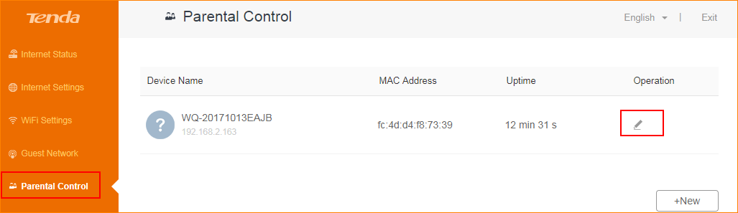

Step 3: Finish the settings, tap “Save”.

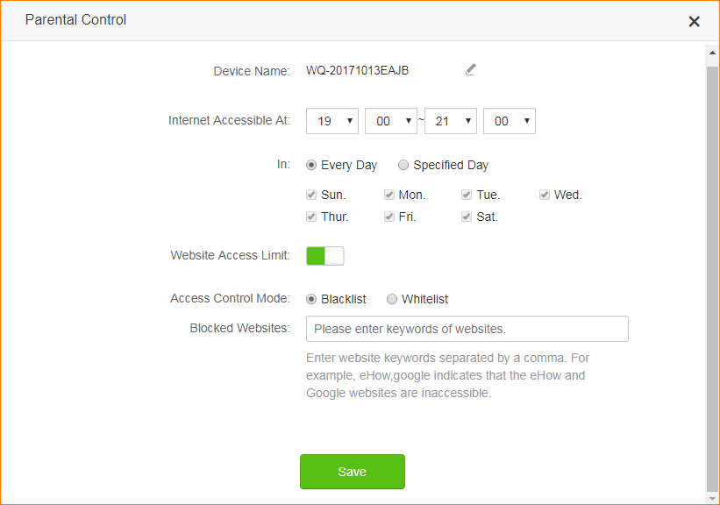
① Devices name: tap to change device name for easy distinguishing. Tap “Save” to save the device name.




② Internet Accessible: set up when you allow it to access the internet.

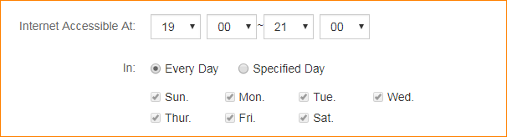
③ Website Access Limit: blacklist specifies what websites are unavailable. Whitelist specifies what websites are available.

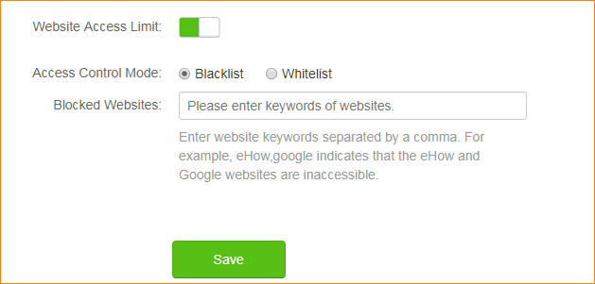

Step 4: If you want to release Parental Control on specified device. Please tap .
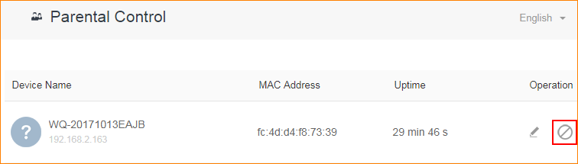
Step 5: If you want to set up Parental Control for this device again, tap .
